FRAMEWORK FOR PREVENTION AND ECO-DESIGN PLAN FOR PHOTOVOLTAIC PANELS

EPR SECTOR: ELECTRICAL AND ELECTRONIC EQUIPMENT
REGULATORY FRAMEWORK
Article L. 541-10-12 of the French Environment Code stipulates that "All producers mentioned in Article L. 541-10-1 are required to produce and implement a prevention and eco-design plan.
This plan is revised every five years. It may be individual or common to several producers. It includes an assessment of the previous plan and defines the prevention and eco-design objectives and actions to be implemented by the producer over the next five years. The producer responsibility organization stablished by the producers may develop a common plan for all its members.
Individual and common plans must be submitted to the producer responsibility organization, which publishes a summary accessible to the public, after presentation to the representative organization of the industry's partners.”
The main regulatory provisions for the photovoltaic sector are defined in article L. 541-10-12 of the French Environment Code. Eco-design criteria must achieve the following three objectives:
- Category A: Reduction of non-renewable resources.
- Category B: Increasing use of recycled materials.
- Category C: Increasing the recyclability of equipment.

WORK CONTEXT
The framework of the prevention and eco-design plan proposed by SOREN has been developed on the basis of the results of the study carried out by CEA INES (Institut National de l'Énergie Solaire) and volunteer photovoltaic industry operators.
With the aim of defining eco-design criteria, the results of this study « Mise en place des critères d'éco-conception applicables à la filière photovoltaïque » (Implementation of eco-design criteria for the photovoltaic industry) are available from our website.
All the eco-design criteria integrated into the plan:
- Are structured around three regulatory objectives (Categories A, B and C).
- Are based on detailed research, including an exhaustive literature review and around thirty interviews/discussions with various key operators in the photovoltaic industry (manufacturers, developers, treatment operators, etc.)
- Are based on a participative approach, involving consultation and voting using specific consultation forms, as well as working meetings involving the project's participants.
This methodological approach ensures that environmental and sustainability factors are meticulously considered in the design and production of photovoltaic panels.
We strongly encourage you to study this plan in detail, and to consider integrating it into your future prevention and eco-design strategies and initiatives.
FRAMEWORK FOR PREVENTION AND ECO-DESIGN PLAN
SOREN supports its members in implementing their individual prevention and eco-design plans, by proposing the adoption of this framework.
The criteria proposed by the producer responsibility organization SOREN can be consulted in further detail in the study « Mise en place des critères d'éco-conception applicables à la filière photovoltaïque ».
If the criteria suggested in the plan's framework do not correspond to what you have implemented or are planning in your prevention and eco-design approach, you can also highlight your approaches and initiatives in the "OTHER INITIATIVES" section.
Consequently, there is no obligation to adopt all the criteria presented. The key is to identify the options that are most relevant to your internal prevention and eco-design approach, and those for which your organization is prepared to make the effort required to implement them.
However, members have the option of using their own frames. If this is the case, it can be uploaded to our website.
Category A | Reduction of non-renewable resources
Criterion P1  "Carbon footprint threshold" | Criterion P1 "Carbon footprint threshold" is defined as follows:  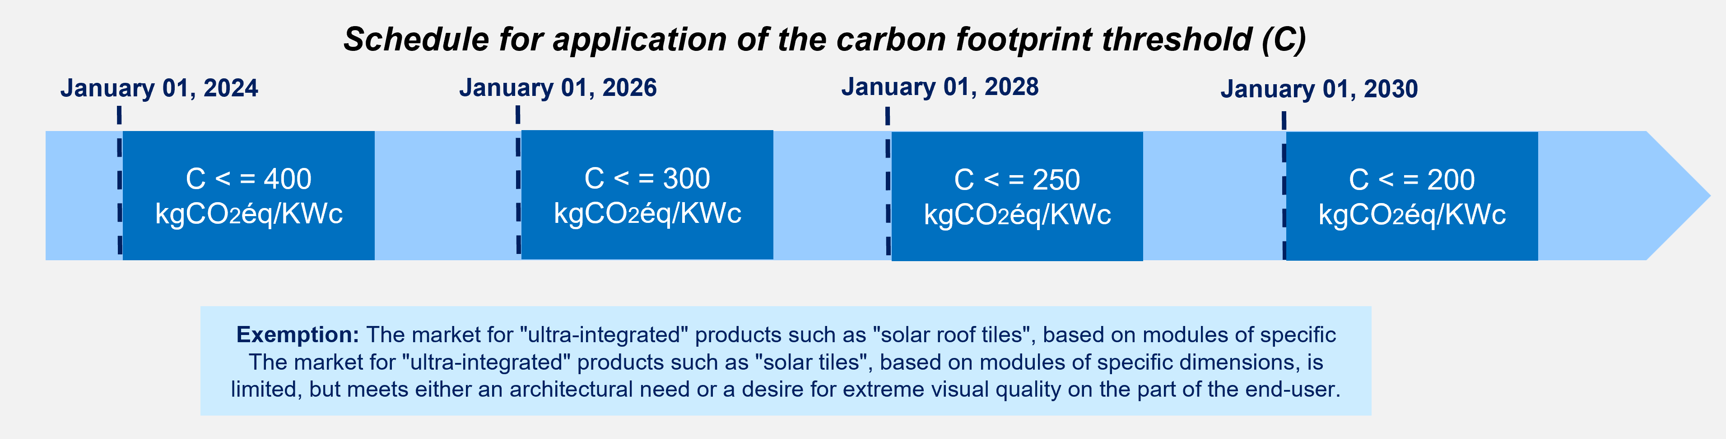  The Simplified Carbon Evaluation (ECS) method currently used to assess the carbon footprint of CRE AO projects will be adopted for calculating the carbon footprint threshold. The same traceability model will also be adopted.  For more details on this criterion, see section "3.1 Critère P1: Seuil Bilan Carbone (C)" of the reference document.  ☐ Criterion adopted ☐ Criterion not adopted
Criterion P2  "Silver quantity threshold" | Criterion P2 "Silver quantity threshold" is defined as follows:  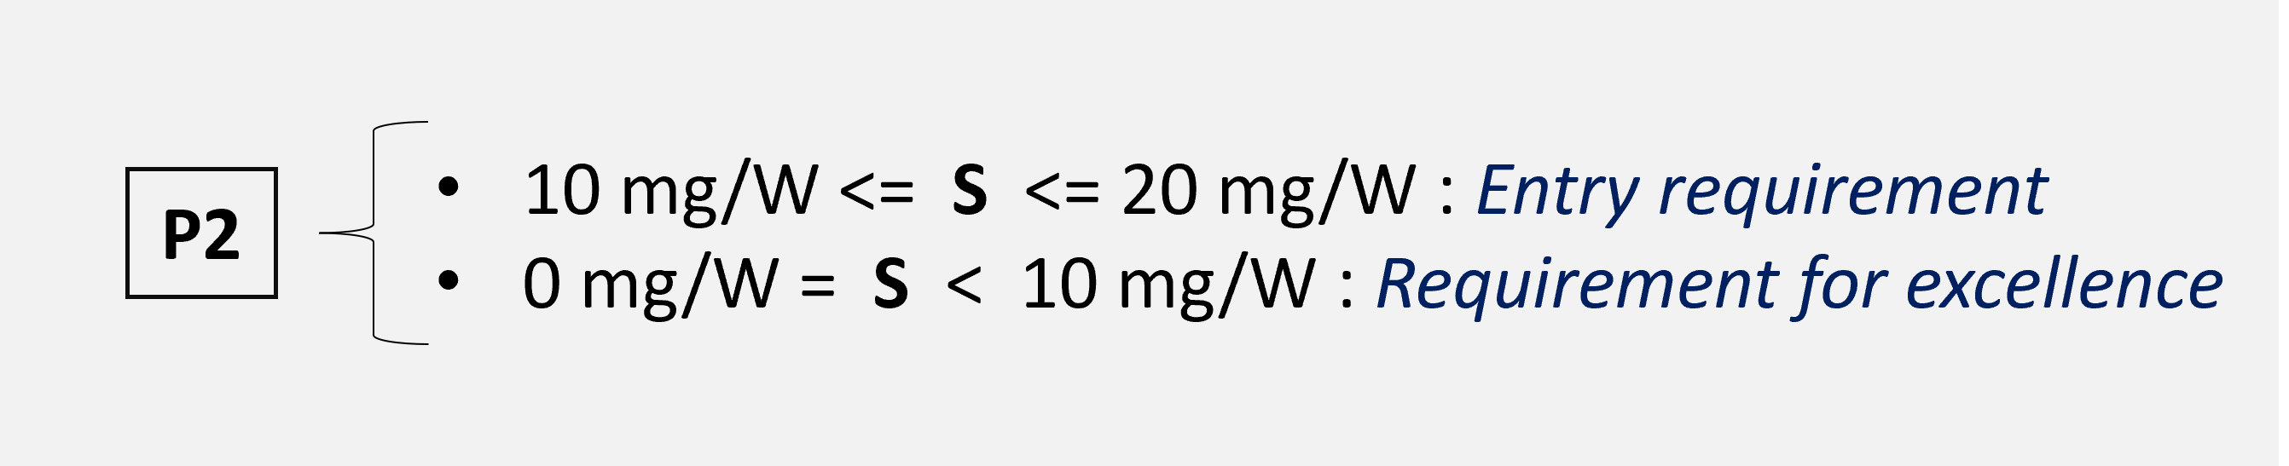  For more details on this criterion, see section "3.2 Critère P2: Seuil quantité d’argent" of the reference document.  ☐ Criterion adopted ☐ Criterion not adopted

Criterion P3  "Product warranty" | Criterion P3 "Product warranty" is defined as follows:  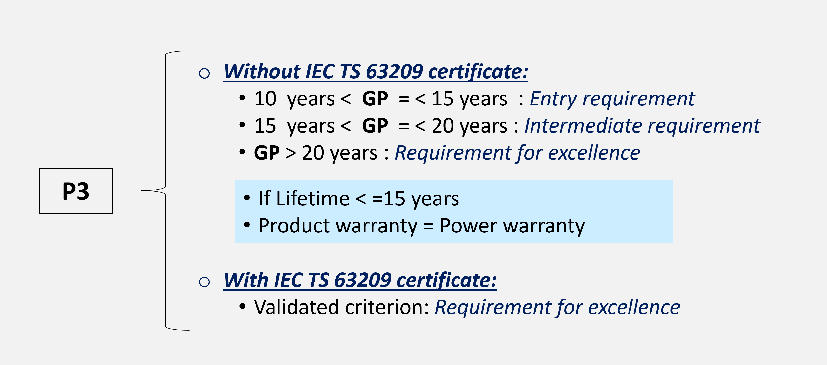  This is the IEC TS 63209 standard, which offers extensive stress tests to ensure the long-term safety and quality of the modules. Another alternative is the module product warranty, which legally commits the manufacturer to the quality of the modules and can be used as an indicator to qualify module quality.  For more details on this criterion, see section "3.3 Critère P3: Garantie produit" of the reference document.  ☐ Criterion adopted ☐ Criterion not adopted
Category B | Increasing use of recycled materials
Criterion P4  “Recycled content rate” | Criterion P4 "Recycled content rate" is defined as follows:  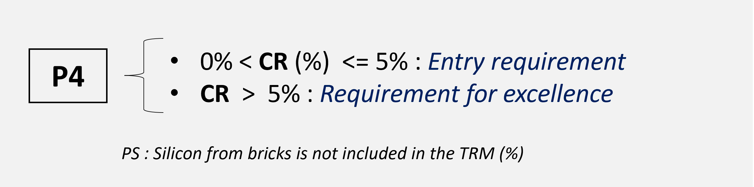  For more details on the calculation method, see section "4.1 Critère P4: Taux du contenu recyclé" of the reference document.  For an example of how to calculate the recycled content rate, please refer to Appendix 5 of the reference document.  ☐ Criterion adopted ☐ Criterion not adopted
Category C | Increasing the recyclability of equipment
Criterion P5  “PV modules without recycling disruptors” | Criterion P5 "PV module without recycling disruptors" is defined as follows:  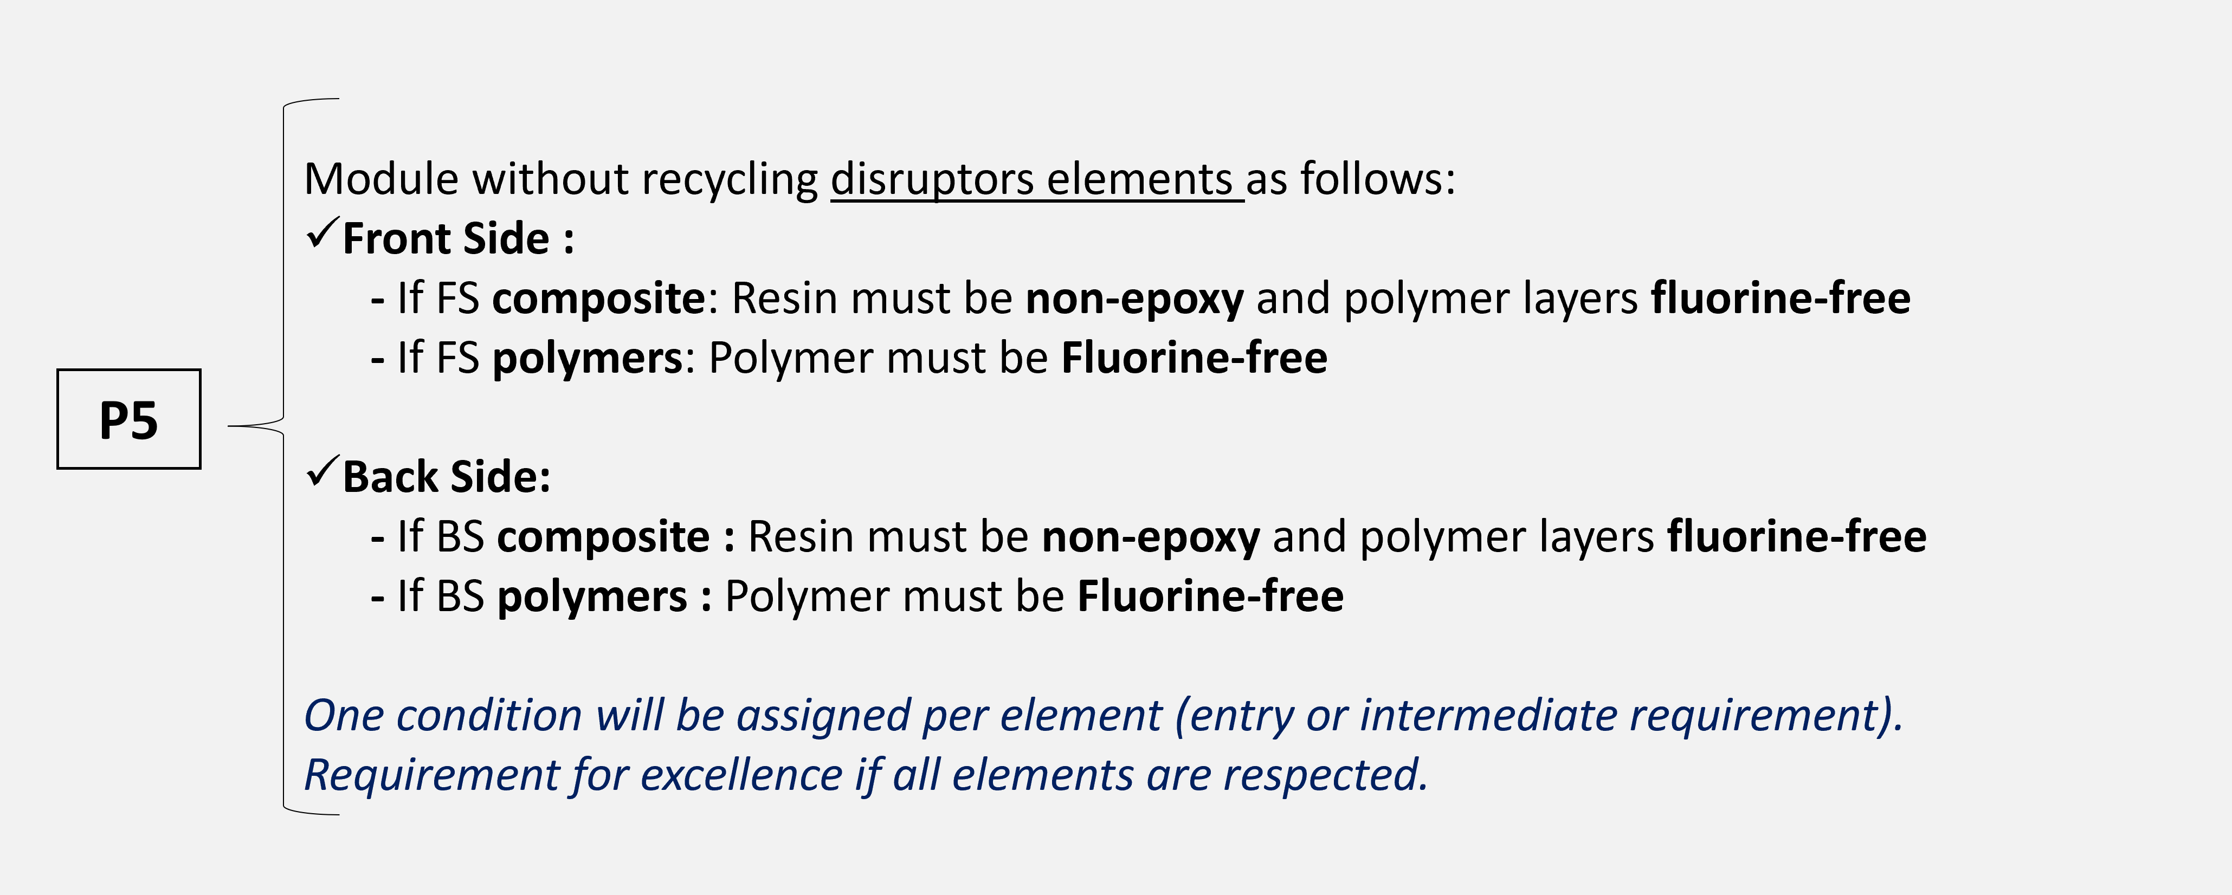  A disruptor is defined as any element that can block the recycling and recovery of materials in the module: either a component that cannot be recycled, or a component that can be recycled but is not compatible with existing processes. In addition to the fact that a component or its recycling may increase the environmental impact of the end-of-life phase, these disruptors involve additional economic costs.  For more details on the calculation method, see section "5.1 Critère P5: Module PV sans élément perturbateur du recyclage" of the reference document.  ☐ Criterion adopted ☐ Criterion not adopted
Criterion P6  "Solar glass marking” | Criterion P6 "Solar glass marking" is defined as follows:  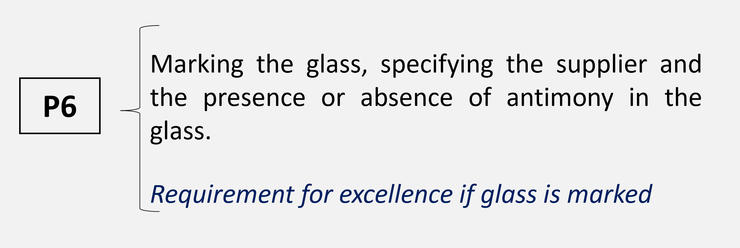  On average, glass represents over 60% of the total weight of a module today. Glass recycling is an important objective in the implementation of circularity.  Marking glass to indicate the supplier and the presence/absence of antimony would appear to be an effective solution for facilitating recycling and increasing the circularity of the photovoltaic sector.  For more details on the calculation method, see section "5.2 Critère P6: Marquage du verre" of the reference document.  ☐ Criterion adopted ☐ Criterion not adopted
Criterion P7  “Hazardous substances” | Criterion P7 "Hazardous substances" is defined as follows:  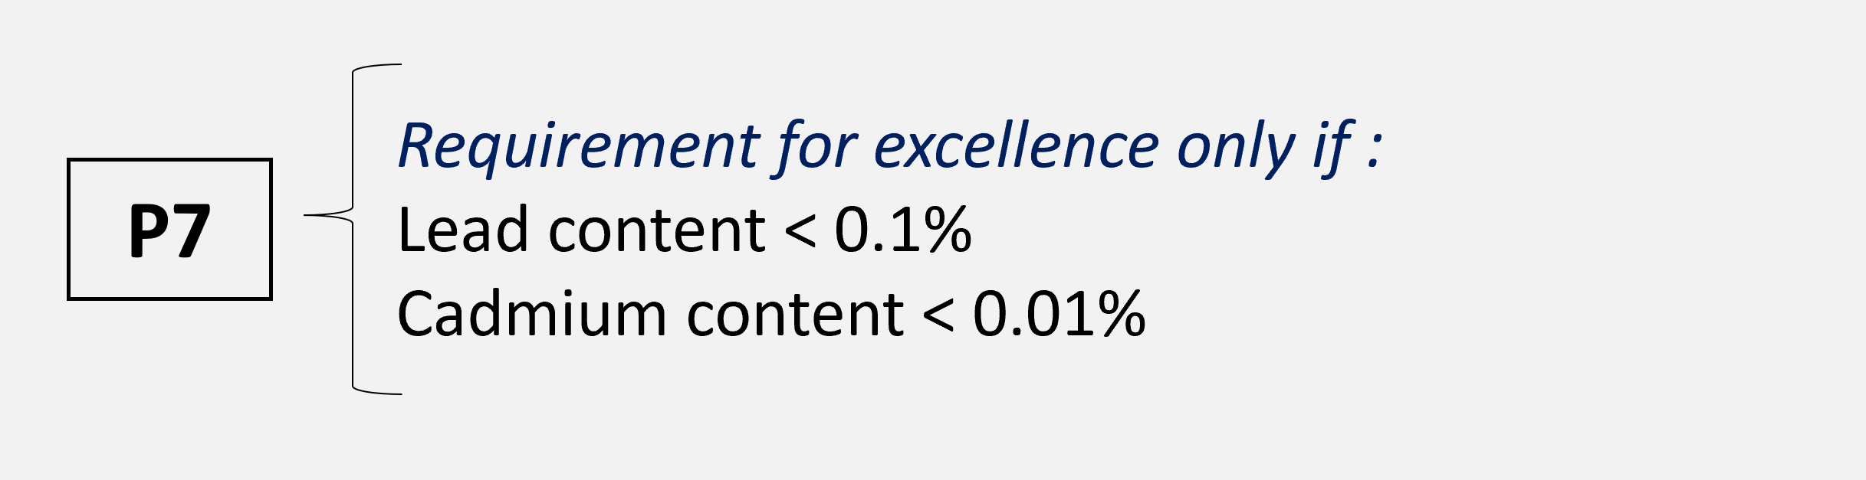  The presence of hazardous substances can increase the environmental impact of the PV module during the manufacturing and end-of-life phases. Lead and cadmium have been identified as hazardous substances requiring further attention.  For more details on the calculation method, see section "5.3 Critère P7: Substances dangereuses" of the reference document.  ☐ Criterion adopted ☐ Criterion not adopted

OTHER INITIATIVES
Category A | Reduction of non-renewable resources
Criterion PX
"Individual criterion”
Category B | Increasing use of recycled materials
Criterion PX
"Individual criterion”
Category C | Increasing the recyclability of equipment
Criterion PX
"Individual criterion”

IDENTIFICATION OF THE ORGANIZATION (Member)
Company name | To be completed
Unique identifier* | To be completed
*Accessible from your Moebius account

POINT OF CONTACT
Provide the professional details (surname/name, job title, e-mail address, telephone number) of the person responsible for completing the prevention and eco-design plan.

Name SURNAME | To be completed
Job title | To be completed
E-mail address | To be completed
telephone number | To be completed

DATE OF APPLICATION
- Date of application: Indicate the date on which your prevention and eco-design plan will be implemented.
- Latest update date: The prevention and eco-design plan must be reviewed at the latest 5 years after it has been produced.

Date of application | day/month/year format
Latest update date | day/month/year format

I, the undersigned NAME SURNAME, in my capacity as JOB TITLE, declare that the COMPANY will apply the above prevention and eco-design plan in accordance with Article L.541-10-12 of the French Environment Code.

Date of signature

Signature Name Surname

